Module Name: Patient Registration – Functional Test Cases
Test Case ID: ST_01
Webpage URL: https://comfy-begonia-b38a58.netlify.app/ttps://comfy-begonia-b38a58.netlify.app

● Scenario ID: BUG-01
Scenario: Register with valid patient details
Test Steps:
- Open Patient Registration website.
- Enter all required patient details.
- Submit the registration form.
Test Input:
Name: Asha Patel
Age: 35
Phone: 9876543210
Gender: Female
Patient ID: PT-1001
Expected Result: Patient should be registered successfully and a confirmation message should be displayed.
Actual Result: Patient registered successfully
Status: Pass
Comments: Positive flow using valid patient details.
Screenshots:
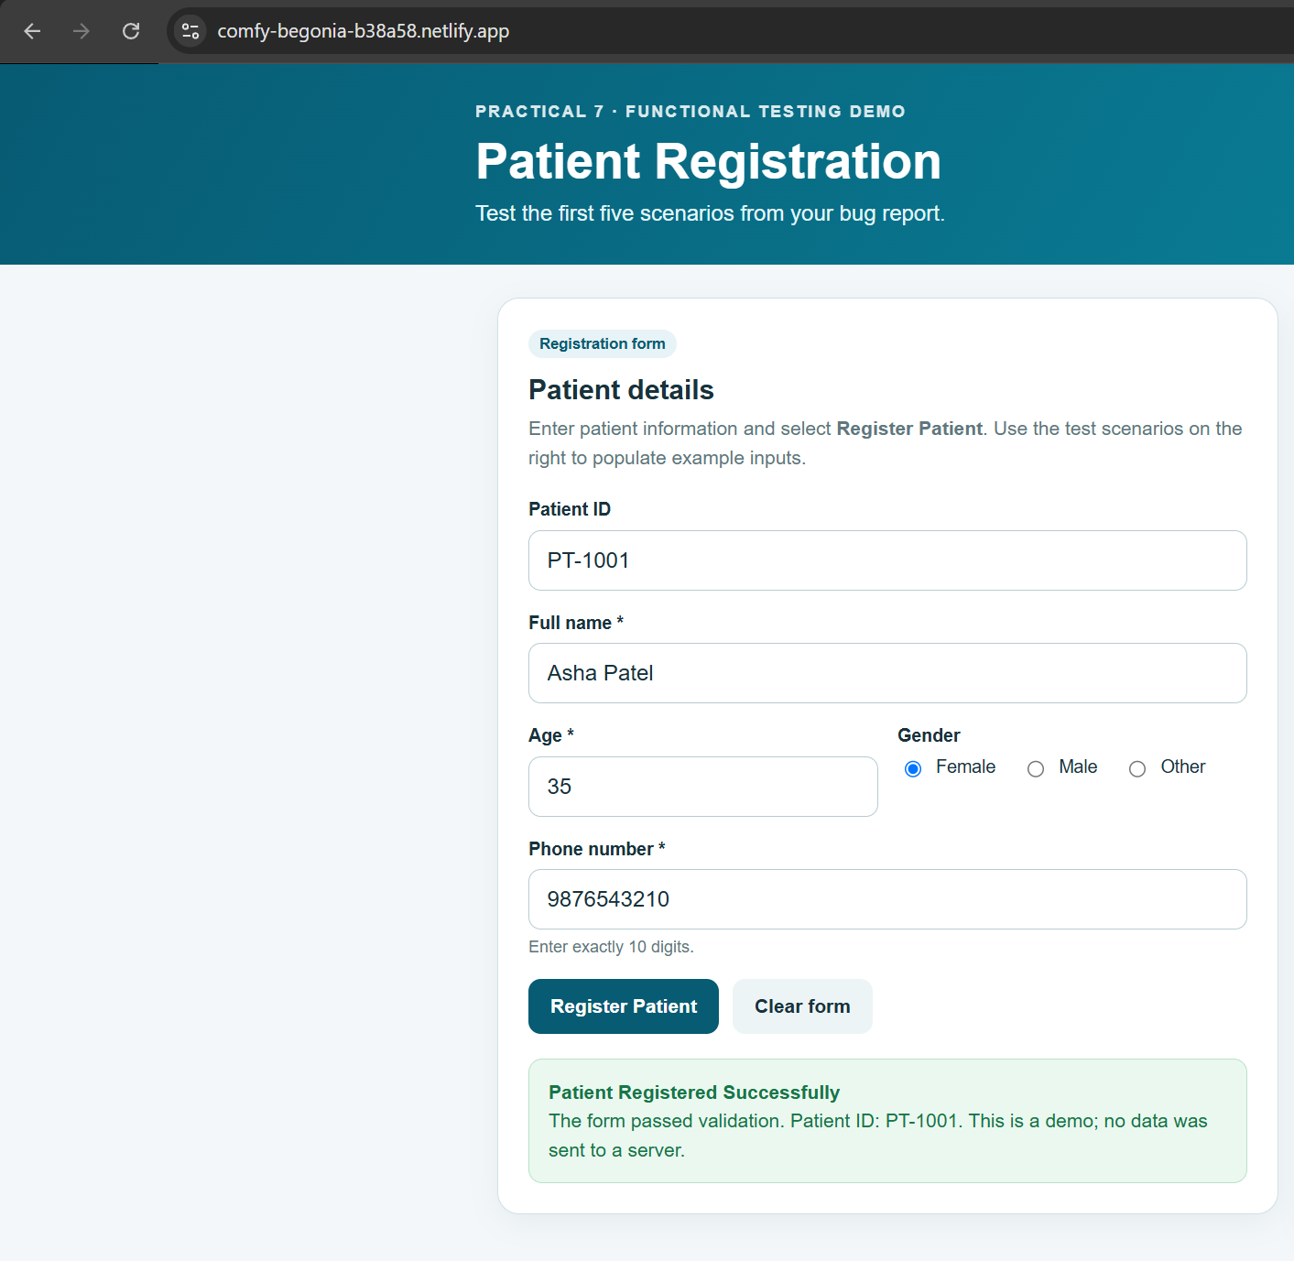

● Scenario ID: BUG-02
Scenario: Register with age above 120 years
Test Steps:
- Open Patient Registration website.
- Enter age as 121 and complete the other required fields.
- Submit the registration form.
Test Input:
Age: 121
Other required fields: valid values
Expected Result: System should display “Invalid Age” and reject registration.
Actual Result: Enter an age from 0 to 120. Registration was not completed.

Status: Pass
Comments: Boundary validation for age above 120.
Screenshots:
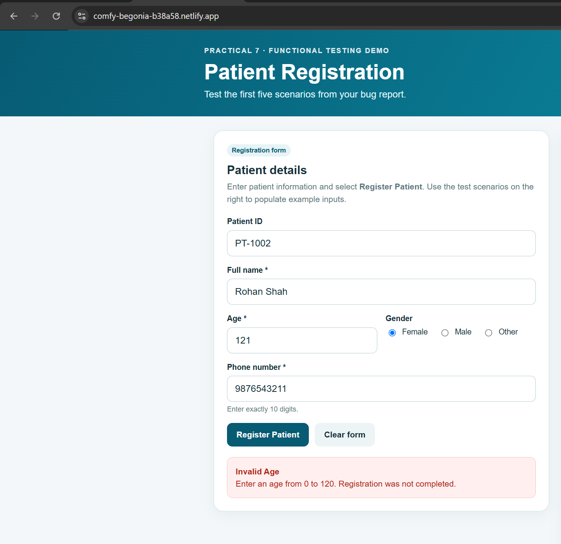

● Scenario ID: BUG-03
Scenario: Register with empty patient name
Test Steps:
- Open Patient Registration website.
- Leave the patient name field blank.
- Complete the other required fields.
- Submit the registration form.
Test Input:
Name: blank
Other required fields: valid values
Expected Result: System should display “Patient Name is Required” and prevent registration.
Actual Result: Please enter the patient’s full name. Registration was not completed.
Status: Pass
Comments: Required-field validation for patient name.
Screenshots:
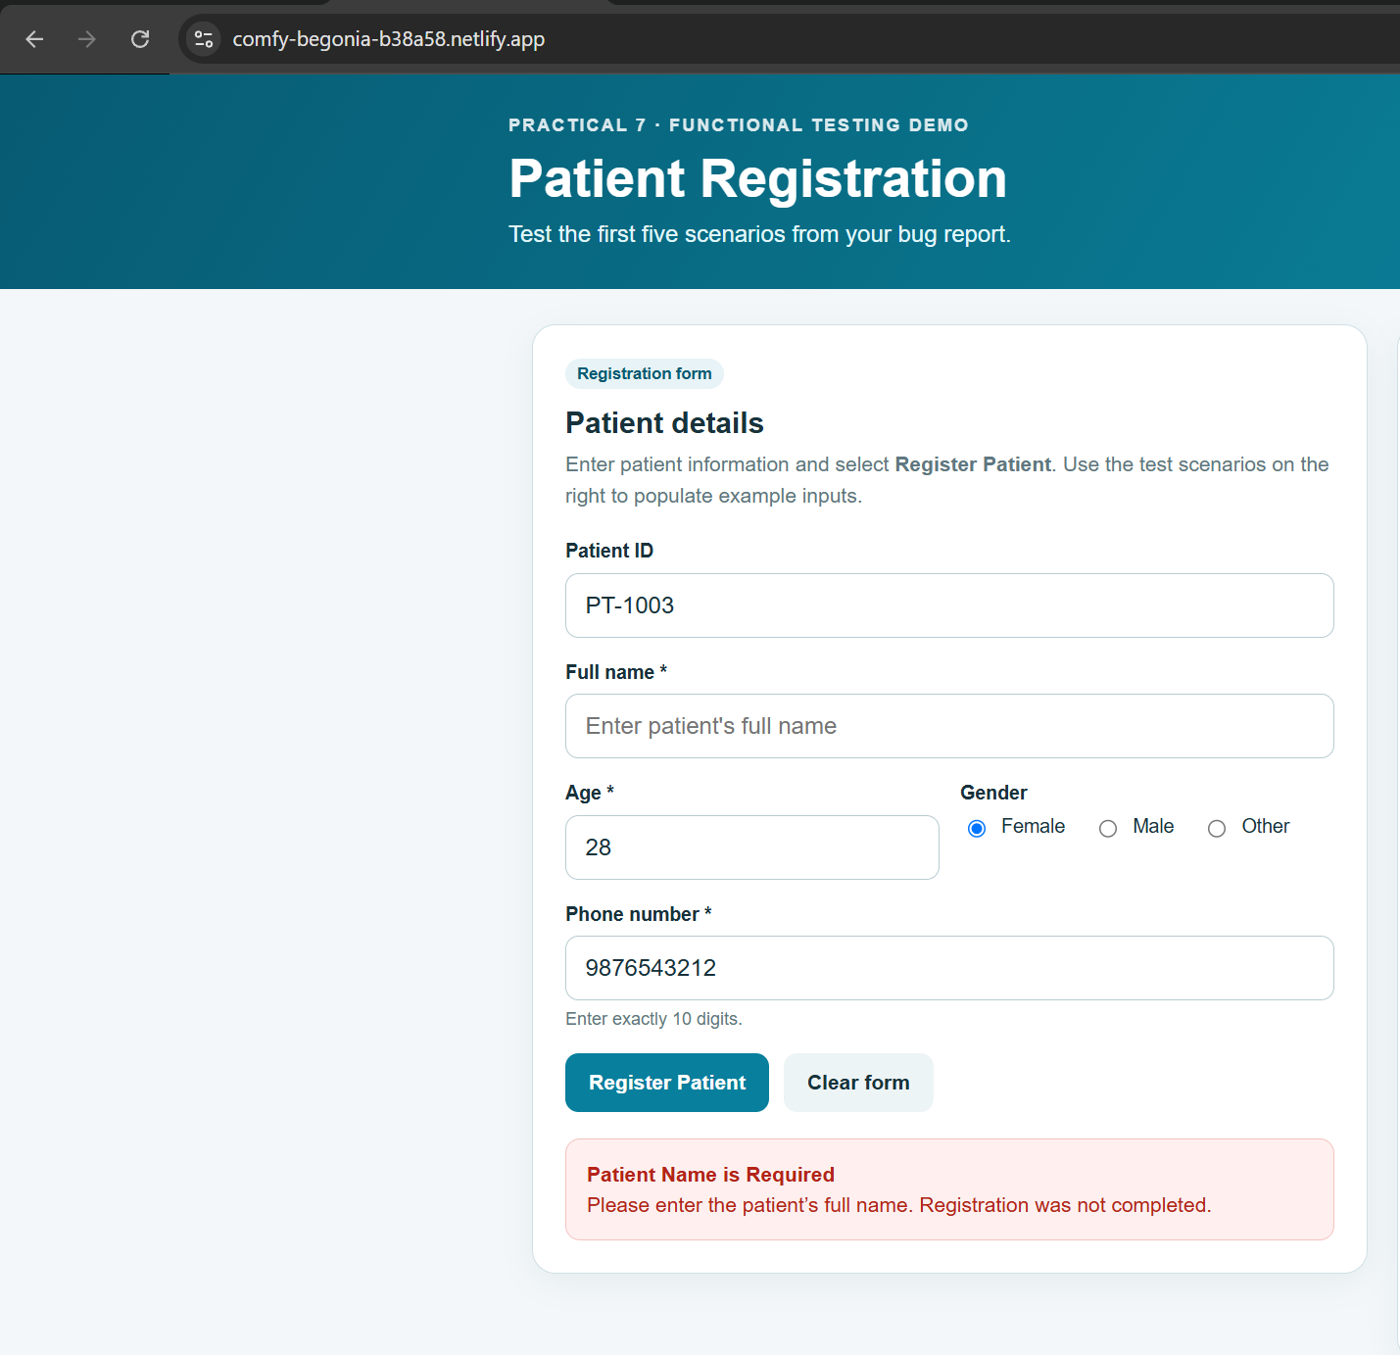

● Scenario ID: BUG-04
Scenario: Register with invalid phone number
Test Steps:
- Open Patient Registration website.
- Enter a phone number with fewer than 10 digits.
- Complete the other required fields.
- Submit the registration form.
Test Input:
Phone: 12345
Other required fields: valid values
Expected Result: System should display “Invalid Phone Number” and reject the phone number.
Actual Result: Enter a phone number containing exactly 10 digits. Registration was not completed.
Status: Pass
Comments: Phone number format validation.
Screenshots:
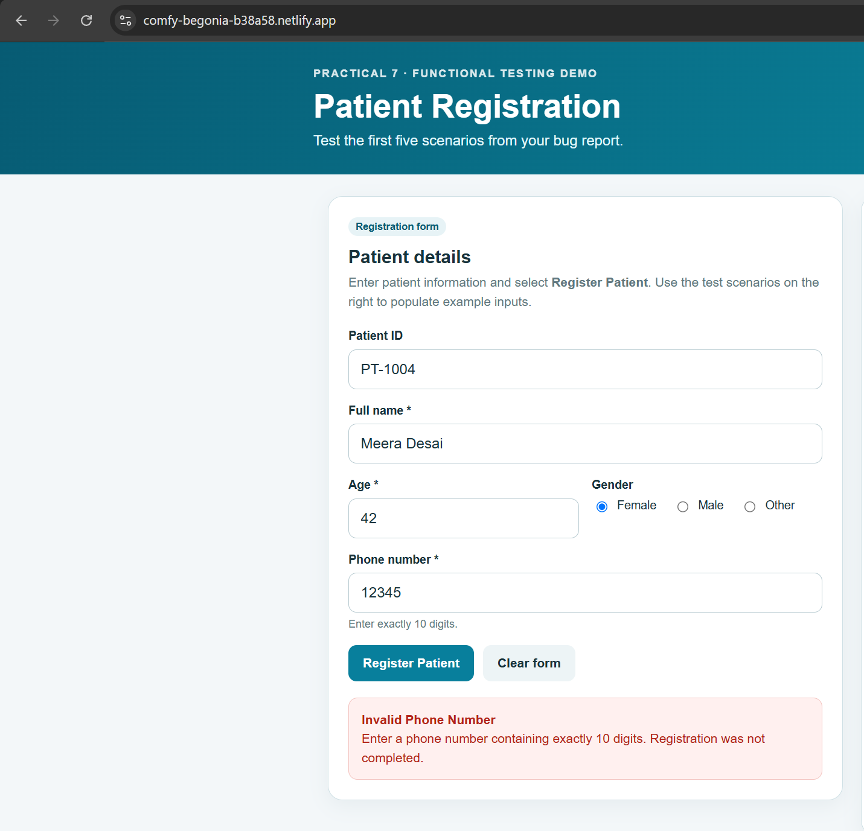

● Scenario ID: BUG-05
Scenario: Register with negative patient age
Test Steps:
- Open Patient Registration website.
- Enter age as -5 and complete the other required fields.
- Submit the registration form.
Test Input:
Age: -5
Other required fields: valid values
Expected Result: System should display “Invalid Age” and prevent registration.
Actual Result: Enter an age from 0 to 120. Registration was not completed.
Status: Pass
Comments: Boundary validation for negative age.
Screenshots:

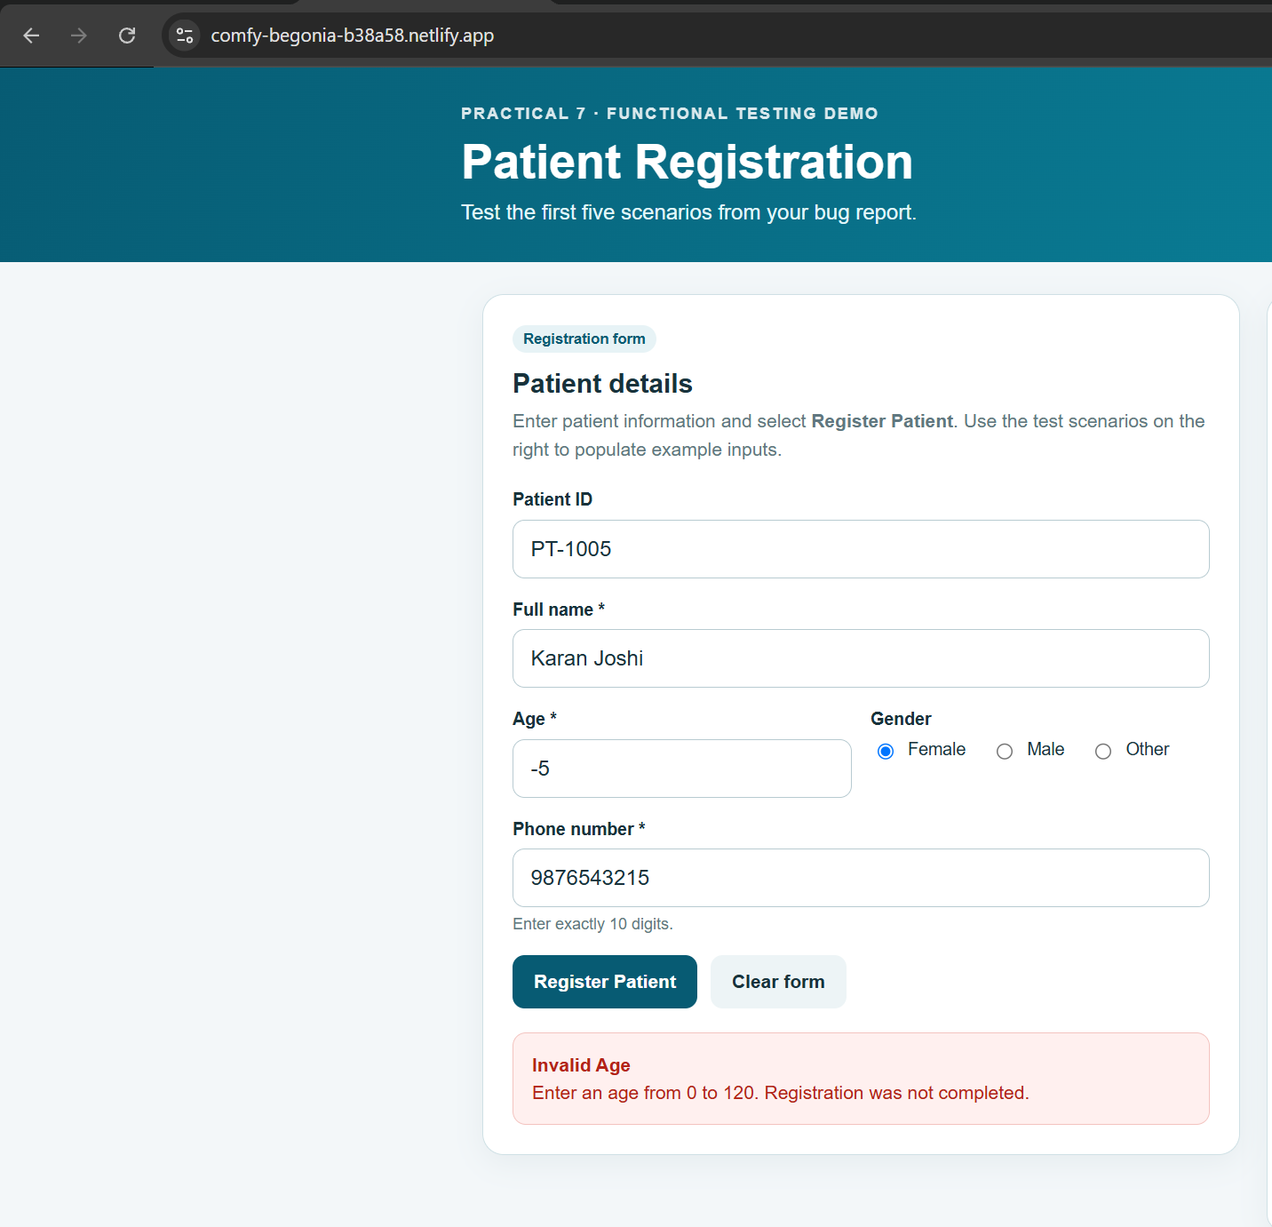
● Summary of Test Results
Total Test Cases | 5
Passed | 5
Failed | 0
Not Executed | 0
Pass % | 100
● Conclusion
The patient registration test report covers five functional test scenarios designed to assess successful registration and the handling of invalid patient information. The scenarios address valid patient details, age boundaries, a missing patient name, invalid phone-number format, and duplicate patient identifiers. Actual results and final pass/fail statuses must be recorded after each scenario is executed on the testing website.
● Recommendations
Execute each test scenario and compare the observed result with the expected result.
Validate that patient ages below 0 and above 120 are rejected with a clear and appropriate error message.
Ensure that the patient name is mandatory and that registration is blocked when the name field is blank.
Confirm that phone numbers are accepted only when they contain exactly 10 digits.
Verify that the system prevents duplicate patient identifiers and displays a clear notification.
Capture screenshots showing the test input and resulting message, and insert them into the designated screenshot areas. ● Conclusion
The patient registration test report covers six functional test scenarios designed to assess successful registration and the handling of invalid patient information. The scenarios address valid patient details, age boundaries, a missing patient name, invalid phone-number format, and duplicate patient identifiers. Actual results and final pass/fail statuses must be recorded after each scenario is executed on the testing website.
● Recommendations
Execute each test scenario and compare the observed result with the expected result.
Validate that patient ages below 0 and above 120 are rejected with a clear and appropriate error message.
Ensure that the patient name is mandatory and that registration is blocked when the name field is blank.
Confirm that phone numbers are accepted only when they contain exactly 10 digits.
Verify that the system prevents duplicate patient identifiers and displays a clear notification.
Capture screenshots showing the test input and resulting message, and insert them into the designated screenshot areas.

